Workplace Attitudes and Disability

Perceptions Drive Opportunity and Experience

Perceived Attitudes of Colleagues Determine Openness
Consistent across Return on Disability Group (RoDG) studies is that it is people, not “stuff” that most determines the experiences of People with Disabilities (PWD). This is true for both consumer and employment experiences. For consumers, interactions with customer service staff tend to be key drivers of experience, while in the workplace, it is interactions with managers, colleagues, and customers, usually in that order, that largely determine whether a career is perceived as positive or negative.
As part of our quarterly research program, RoDG conducted two parallel surveys: one assessing the workplace perceptions and experiences of PWD, and another examining the attitudes of people managers on topics of workplace diversity and PWD in the workplace.
As part of the first survey, PWD were asked to rank the largest barriers to openly discussing disability in the workforce. The top-ranked barrier to discussing disability was the perceived attitudes of managers. This finding is not surprising, given the influence of managers on career trajectories. The second ranked barrier was attitudes of co-workers.

Negative Comments Frequent
Survey responses suggest that PWD often directly encounter stigma pertaining to disability at work. When asked if they had ever received negative comments at work due to their disability, 43% of respondents indicated yes. For those that had received negative comments at work, 65% indicated they had received such comments from peers, 40% indicated they had received them from managers, and 13% indicated they had received them from subordinates. 8% of those who received negative comments did so from alternate sources, the majority of which were directly from customers or members of the public they were interacting with in their work role.
Figure 1: From whom did you receive negative comments [about your disability]?
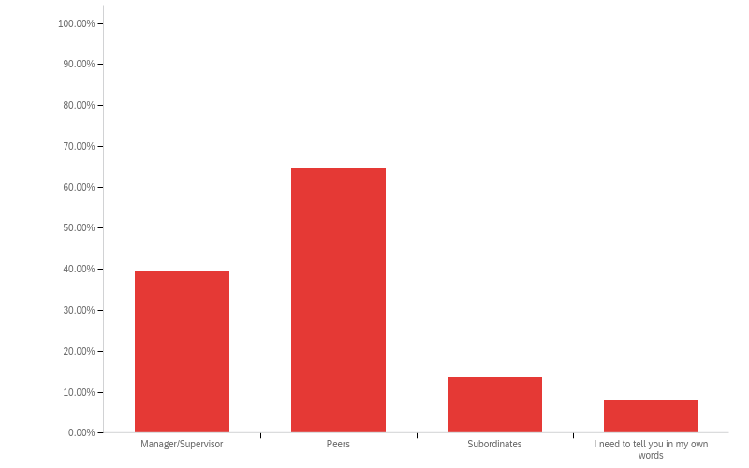

Concerns of Managerial Attitudes Well Founded
While the majority of PWD respondents did not directly encounter negative comments about their disability from managers, their general perception that manager attitudes discourage open discussions of disability are well founded. When managers were asked to rank their concerns with hiring PWD as employees, the top ranked response was concerns about PWD’s ability to do the job effectively, followed by the cost of accommodations.
Figure 2: What do you think are the main concerns for hiring People with Disabilities?
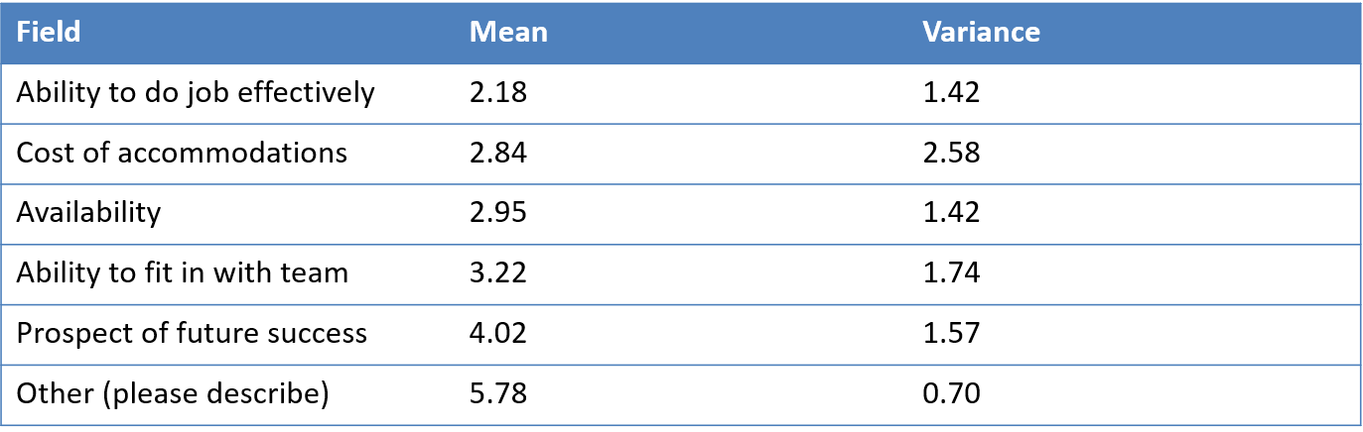
It should be noted that 60% of managers did not believe they had a PWD on their team, despite both the size of this demographic (27% of the Canadian population), and that 85% of surveyed respondents described their teams as “somewhat” or “very” diverse.

Why this Matters
At the senior level, managers frequently conceptualize disability as being about “stuff”: accessible washrooms, ramps, and other capital-intensive changes to built environments. However, key drivers of experience are often at the personnel level, inhibiting both openness and the workforce and breaking relationships between PWD and their managers and peers.
The solution to these (accurately) perceived attitudes in the workplace is multifaceted. While training certainly has a role, in of itself, it is insufficient to address these concerns. Rather, organizations should be working to eliminate the need for disclosure to receive the necessary productivity adjustments currently conceptualized as accommodations. Doing so removes pressure to discuss disability in a context that may create negative repercussions for employees, while simultaneously encouraging non-PWD to maximize their own efficiencies by obtaining such adjustments. Finally, senior management must instill accountability for creating positive workplace experiences. Failure to do so risks alienating up to a quarter of a given organizations workforce, and by doing so, encouraging them to pursue their careers elsewhere.

Accessibility of this document
This document respects various best practices regarding accessible documents, including our choice of typeface, type size, hue contrasts, margins, document structure, and heading styles.

This document complies with all applicable EN 301 549, WCAG 2.0 and 2.1 Level A and Level AA guidelines for accessible digital documents. For alternative formats, contact Return on Disability at mark@rod-group.com. We always strive for plain language; however, we often cannot write about topics such as conformance and compliance using simpler language without losing critical meaning.
© The Return on Disability Group. All rights reserved. The information contained herein is not represented or warranted to be accurate, correct, complete or timely. This report is for information purposes only and should not be considered a solicitation to buy or sell any security.
Return on Disability quarterly surveys, third quarter 2022. N=825 self-identified PWD and 208 self-identified managers.

