Manager Representation Effects

A Key Driver of PWD Employee Engagement

Discussions of Disability in the Workforce
In part due to regulation, there is a heavy emphasis within organizations on having employees disclose their disability. This is often a necessary precursor to receiving workplace accommodations and fulfills organizational requirements for a diverse workforce. To this end, many advocacy organizations work on promoting cultures of openness and/or on encouraging People with Disabilities (PWD) to disclose their disability to receive accommodations.
However, this emphasis on disclosure misses a key element: the potential negative effects of disclosure must be balanced against potential gains from workplace accommodations (providing accommodations are the reason for disclosure). One key finding from RoDG’s 2022 third quarter survey on disability is that managers often perceive PWD as being unable to their job effectively.
Despite 27% of the North American population having a disability, many PWD are unaware there are other PWD at their given employer. In RoDG’s third quarter survey of PWD employees, only 45% of respondents indicated they knew of other PWD that discussed their disabilities in their workplace, while 55% indicated they did not know other PWD who discussed their disability at work.
Figure 1: Are there other People with Disabilities that discuss their disabilities at your workplace?
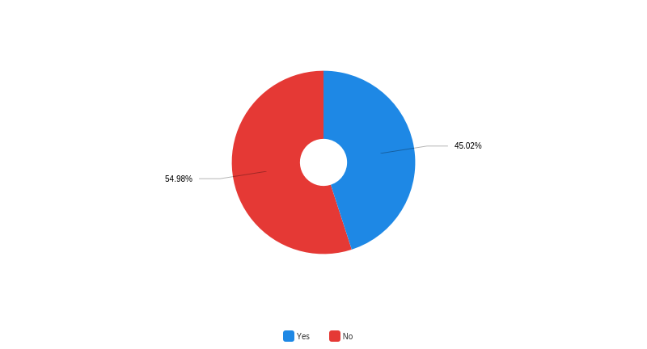

Disability Openness and Managers
Public discussion of disability among managers is even less than those with more junior roles in an organization, at least that such that the majority of workers perceived. While 45% of survey respondents indicated they knew of another PWD who openly discussed their disability at work, only 19% were aware of a manager or company leader that had a disability. This result is not surprising, given that RoDG research has consistently indicated that stigma surrounding disability makes upward mobility in an organization more difficult. However, it should be noted that external research has indicated up to 30% of white collar workers have a disability – suggesting a relative culture of silence among managers and senior leaders with disabilities in many organizations.
Figure 2: Do any of your managers or company leaders have a disability that you are aware of?
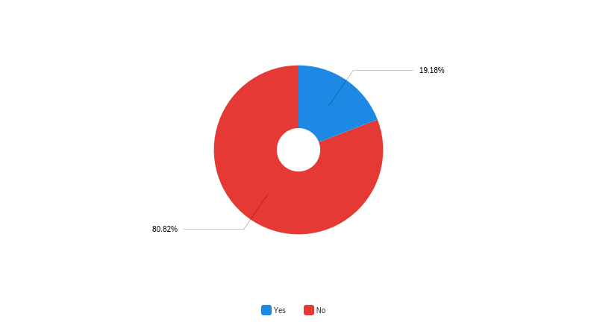

Openness Among Leaders Improves Engagement
While openness amongst leaders and managers was relatively rare, when it did occur, it had a significant impact on employee engagement. Respondents who knew of a manager or leader with a disability more frequently had workplace accommodations (thus improving their productivity), reported greater satisfaction with their manager, were more comfortable discussing disability at work, and were nearly twice as likely to disclose their disability when hiring. Moreover, those that knew of a manager or leader with a disability perceived greater opportunity for advancement in their organization: a key driver of employee engagement. Those that knew of a manager or leader in their organization were 12% less likely to indicate disability “probably” or “definitely” made career progress more difficult relative to their disability, and were 15% more likely to indicate disability “probably” did not or “definitely” did not make career progress more difficult. It should be noted that even with a manager or leader with a disability, nearly half (48%) of respondents indicated disability made career advancement more difficult.
Figure 3: Do you feel having a disability makes career advancement more difficult, relative to your disability? Broken down by if knew manager or leader with a disability at their workplace.
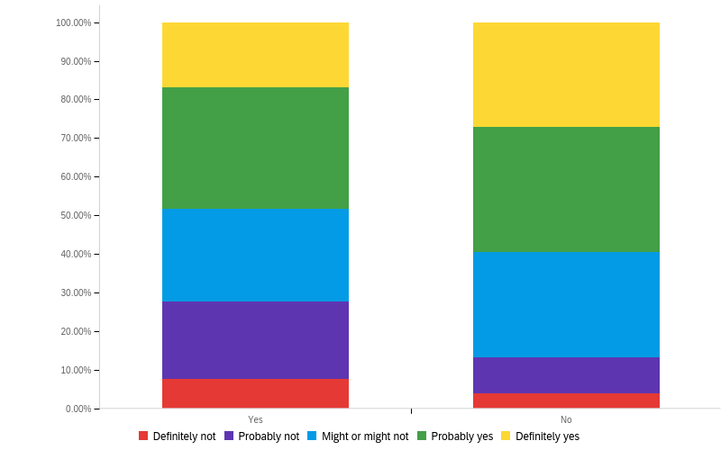

Why this Matters
At present companies consistently fail to properly engage employees with disabilities. This results not only in poorer retention, but also reduced productivity. Despite the size of the disability population, most PWD do not know of other PWD within their organization – especially at management levels. This likely amplifies concerns over career success at an organization, encouraging top talent to look elsewhere to fulfill their career ambitions.
Having management that is open about having a disability can have a significant effect on employee engagement down the ranks – from requesting accommodations, to perceptions of upward mobility. However, while organizations should strive to promote top PWD talent, the overall emphasis should be away from disclosure, and towards maximizing productivity in their workforce. While openness in more senior ranks may serve as a stepping stone to this goal, organizations should direct their efforts to eliminating the need for disclosure at all, instead offering a range of productivity enhancing work adjustments to maximize contributions across the workforce – independent of disclosure.

Accessibility of this document
This document respects various best practices regarding accessible documents, including our choice of typeface, type size, hue contrasts, margins, document structure, and heading styles.

This document complies with all applicable EN 301 549, WCAG 2.0 and 2.1 Level A and Level AA guidelines for accessible digital documents. For alternative formats, contact Return on Disability at mark@rod-group.com. We always strive for plain language; however, we often cannot write about topics such as conformance and compliance using simpler language without losing critical meaning.
© The Return on Disability Group. All rights reserved. The information contained herein is not represented or warranted to be accurate, correct, complete or timely. This report is for information purposes only and should not be considered a solicitation to buy or sell any security.
See The Return on Disability Group. 2024. Workplace Attitudes and Disability. Available at: Workplace Attitudes and Disability | Insights | Return on Disability (rod-group.com)
For disability rates in the United States, see Centers for Disease Control and Prevention. 2023. Disability and Health Data System (DHDS)]. Available at: http://dhds.cdc.gov. For Canada, see Statistics Canada 2023. Canadian Survey on Disability, 2017 to 2022. Available at: https://www150.statcan.gc.ca/n1/daily-quotidien/231201/dq231201b-eng.htm.
Lisa Sherbin, Julia Taylor Kennedy, Pooja Jain-Link, and Kennedy Ihenzie, Disability and Inclusion: US Findings Coqual. 2017. Available at https://coqual.org/wp-content/uploads/2020/09/CoqualDisabilitiesInclusion_KeyFindings090720.pdf

