PWD Retail Channel Preferences

Experience Differs Across Channels

Preferences for Digital Experience
A significant shift in retail, amplified by the Covid-19 Pandemic, is that towards online retail, grocery, and banking experiences. The reasons for this are relatively straightforward: not only can some digital retailers offer more competitive pricing due reduced real estate footprints, they also allow consumers to shop from the comfort of their home, often receiving ordered items in a short period of time. From both a cost and time perspective, digital retail offers significant benefits.
For some People with Disabilities (PWD), the benefits of digital retail and banking are amplified. For those with limited mobility, digital experiences can preclude navigating large retail centres or spending time standing in lines, both of which can be uncomfortable. For those with limited vision, digital experiences can allow for the easier identification of products and prices – provided websites and apps are formatted properly. For those with cognitive disabilities, digital spaces can eliminate the need to directly interact with others, provide simple navigation via search bars, and allow for one to approach a retail experience in smaller chunks. Finally, for those without drivers licenses or access to transit, the time saved in digital experiences is enormous.
As part of its 2022 quarterly research program, Return on Disability Group (RoDG) surveyed 810 PWD consumers. Of that group, 46% indicated that in a “perfect world” over 50% of their shopping and banking experiences would be online (including groceries). Approximately 30% of respondents indicated they would prefer 25% of their shopping (or less) to be online.
Figure 1: In a perfect world, what percentage of your shopping and banking would be online?
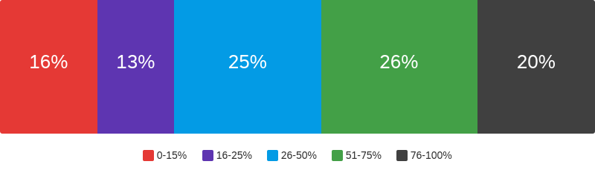

Understanding Current Retail Trends for PWD
At present, more PWD shop or bank in person than they would prefer to do. While 46% of PWD say they would like more than half of their shopping to be online, this is currently the case for only 30% of respondents. This represents a material opportunity for digitization to better serve a massive market segment.
Figure 2: What percentage of your shopping and banking is currently online?
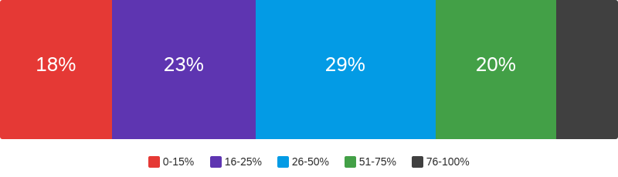
10%

Why Digital? A Comparison of Disability Experience
A key finding of this survey was how participants saw their disability as shaping their retail experiences. Respondents were asked if they believed their disability led to more negative shopping experiences, both in-person and online. 45% of respondents indicated their disability “probably” or “definitely” led to more negative experiences when shopping in person, compared to 28% that did not. In contrast, only 18% of respondents indicated their disability “probably” or “definitely” led to more negative experiences shopping online, while 51% indicated it “probably” or “definitely” did not.
Figure 3: Do you believe your disability leads to a more negative experience when shopping/banking in person?
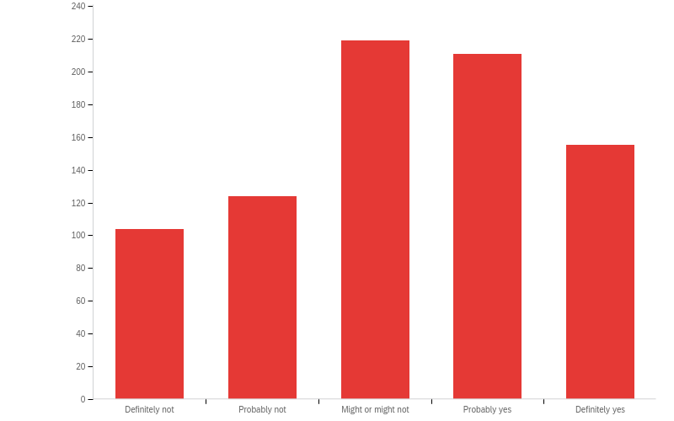
Figure 4: Do you believe your disability leads to a more negative experience when shopping/banking online?
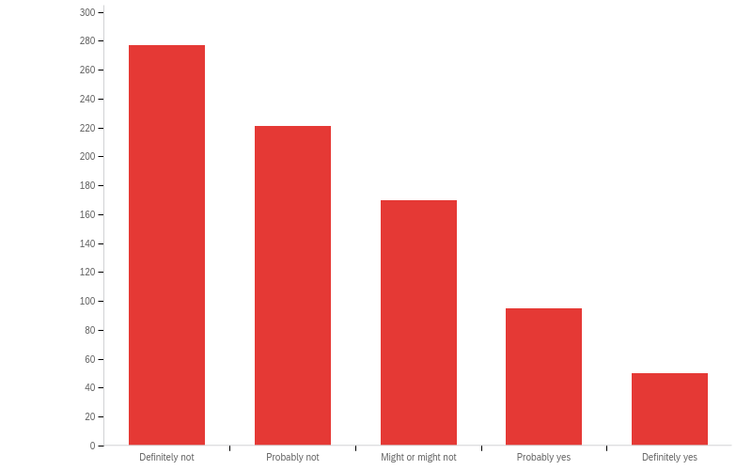

Why this Matters
Most discussions of accessibility begin and end with built environments and WCAG requirements. Missing in this is the service and convenience elements prioritized by all customers. One of the more striking survey findings is that negative experiences for in-person retail were not limited to those with mobility or vision related disabilities, instead, findings were consistent across disability “types”. The same is true for more positive digital experiences.
The implications of this are threefold. First, digital design is key to delighting consumers. Having a clear and useable web interface allows users to shop through their preferred channels, better delivering delight. Second, in-person impediments to experience are not simply built issues, rather (and as other RoDG studies indicate), they are tied with the type of service individuals receive in store. Finally, while there is a general preference for online services, the majority of respondents would maintain some in-person shopping and banking. Ensuring a cross-channel serie4s of experiences, customizable for the user, offers the greatest potential to delight all clients and drive consumer loyalty.

Accessibility of this document
This document respects various best practices regarding accessible documents, including our choice of typeface, type size, hue contrasts, margins, document structure, and heading styles.

This document complies with all applicable EN 301 549, WCAG 2.0 and 2.1 Level A and Level AA guidelines for accessible digital documents. For alternative formats, contact Return on Disability at mark@rod-group.com. We always strive for plain language; however, we often cannot write about topics such as conformance and compliance using simpler language without losing critical meaning.
© The Return on Disability Group. All rights reserved. The information contained herein is not represented or warranted to be accurate, correct, complete or timely. This report is for information purposes only and should not be considered a solicitation to buy or sell any security.
Return on Disability quarterly survey, fourth quarter 2022. N=810 self-identified PWD.

