Customer Service in Retail: Defining the PWD Experience

Accessibility in Interactions

People, not “Stuff”
Over the past 15 years, PWD have consistently told RoDG analysts that the single greatest determinant of their consumer experience is not physical accessibility solutions such as automated doors, but routine interactions with store or branch staff. When done right, human customer service allows PWD to overcome barriers or inconveniences in the retail process, from finding products, to making informed consumer decisions, to easily paying for their chosen product or service. Done poorly, front-line customer service agents can unintentionally fail to meet needs – at times to the extent that the consumer will leave without making their intended purchase and share their negative experience within their social networks. Getting service right for PWD, like any other market, is key to creating brand ambassadors and lifetime customers.

Service as Risk and Opportunity
To what extent does service define experience? One way to address this issue is to ask users what effect customer service has on their consumer habits. As part of its quarterly survey research program, RoDG analysts did exactly this, while also probing on other areas of customer service across the retail and banking sectors. The results of this survey convincingly show the importance of customer service: less than 10% of respondents indicated customer service has no impact on their consumer behaviour. In contrast, 28% indicated poor service caused them to exit scores, 34% indicated good service causes them to buy from stores, and 27% indicated that service defines their experience, including what and where they buy.
Figure 1: How does service quality affect your decisions?
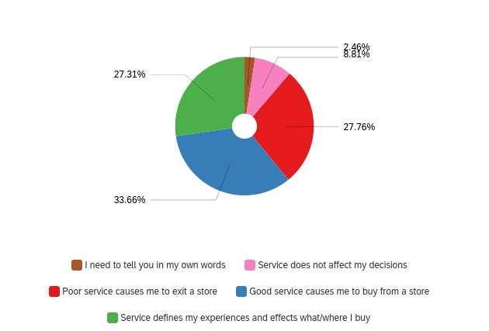
An additional question asked directly if they would choose one brand over another if they provided better service relative to their disability. When asked if the statement “I will choose a brand over another brand when I receive better service in regards to my disability” was true or false, 79% of respondents indicated this was true.
Figure 2: How customer service impacts brand choice
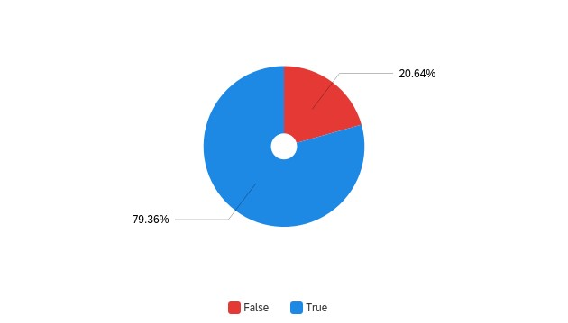

How Frequently do PWD Seek Service Representatives?
Initial impressions of these findings may lead one to assume that PWD conduct their retail transactions with heavy assistance from customer service agents. However, this is rarely the case, regardless of the type of disability a consumer may have. Except for consumers with limited or no vision, over half of PWD only self-report seeking a customer service representative in 0-25% of their consumer experiences. Of that, 10% responded they never seek out such service. Few PWD also report seeking out customer service agents frequently, with only 11% of all respondents indicating they seek out a customer service representative more than 75% of the time. Of differing disability types, those that seek out service frequently in the highest volume are those with limited or no vision, who do so approximately 20% of the time. A full breakdown by disability can be seen in Figure 2, below.
Figure 3: How often do you make use of customer service agents in your shopping or banking experiences? Broken down by disability type
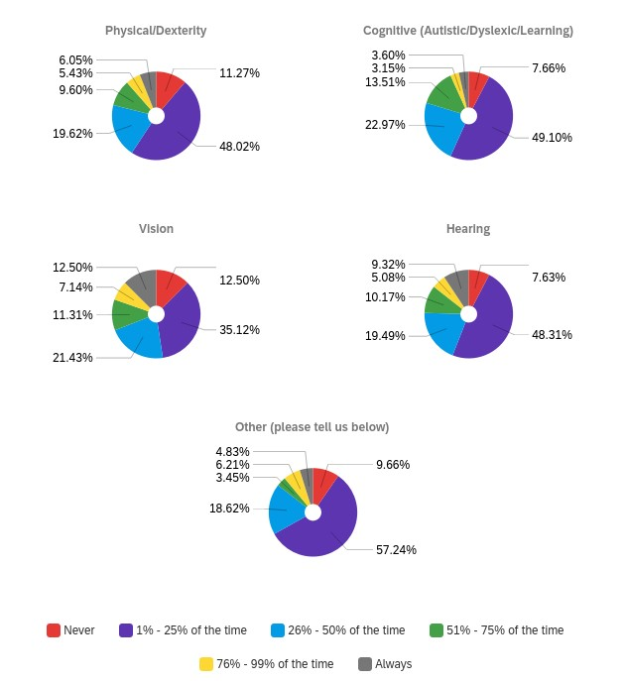
It is essential to underscore when reading these results that each disability type is multifaceted, incorporating a wide range of functionality. This in part explains the high number of responses for both frequent and no use of customer service representative by those with limited vision. It should also be stressed that the nature of certain disabilities makes it more likely that the individual would shop or bank with a companion, thus potentially precluding the need for a customer service representative.

Implications
Customer service is one of, if not the greatest, determinant of consumer experience. It is essential for brands to get this right to create a loyal consumer base and brand ambassadors. Customer service failures are also likely to turn off customers from a brand permanently, with potential ripple effects through this individual’s social network.
It is crucial to note that most retail experiences can now also occur online. Customers now have other options to in-person experiences. Those that choose to shop or bank in person are thus selecting the set of potential experiences unique to this medium – of which live customer service agents are an integral component. Getting this right allows brands to differentiate themselves in an increasingly competitive in-person retail environment, not just for PWD, but their entire customer base.

Accessibility of this document
This document respects various best practices regarding accessible documents, including our choice of typeface, type size, hue contrasts, margins, document structure, and heading styles.

This document complies with all applicable EN 301 549, WCAG 2.0 and 2.1 Level A and Level AA guidelines for accessible digital documents. For alternative formats, contact Return on Disability at mark@rod-group.com. We always strive for plain language; however, we often cannot write about conformance and compliance using simpler language without losing critical meaning.
© The Return on Disability Group. All rights reserved. Access to this report and its contents is provided through a discreet contract between the company named in the report and The Return on Disability Group. Redistribution is prohibited unless provided in writing by both The Return on Disability Group and the named subscriber. The information contained herein is not represented or warranted to be accurate, correct, complete or timely. This report is for information purposes only and should not be considered a solicitation to buy or sell any security.
Return on Disability quarterly survey, fourth quarter 2021. N=806 self-identified PWD.
Return on Disability quarterly survey, fourth quarter 2021

