Accommodations and Productivity: The case against disclosure

Introduction
Most of us are familiar with automated entrances, often with square, silver buttons embossed with an image of a person in a wheelchair. This wheelchair image, with a blue background and posted near ramps or elevators is the widely recognized international symbol of access. This image also reflects a general misunderstanding of what constitutes disability and accommodations.
Between 1-2% of the North American population currently uses a wheelchair for regular mobility needs. At the same time, roughly one quarter of the North American population currently self-identifies as having a functional disability. The majority of these people with disabilities (PWD) are effectively managing disabilities that are nonapparent in most environments and that do not require obvious physical aids such as wheelchairs, scooters, or white canes. Still, these PWD have functional differences in how they interact with the world and the workplace.
Top companies have increasingly realized there is untapped value in hiring employees with disabilities. Provided differences in functionality are considered, employees with disabilities have been observed to take less time off, have greater job satisfaction, and receive higher performance reviews than the “average” worker. On the regulatory side, there has been increased emphasis on hiring PWD in the workforce and eliminating barriers to full employment participation, such as through The Americans with Disabilities Act (ADA), Accessibility Canada Act (ACA), and The European Accessibility Act (EAA).
Unrealized in conversations of PWD in the workplace is that in any company with a sufficiently large workforce, it is likely that at least 20% of the workforce manages a functional disability. They’re just not telling you.
The business implications of non-disclosure is enormous. Currently, almost all businesses require employees with disabilities to disclose their disability to receive an accommodation, yet RoDG research has consistently indicated that most PWD prefer not to disclose. At the same time, in RoDG surveys of employees with disabilities, they consistently indicate that they work significantly harder than their counterparts to achieve the same results. Fewer than 20% of employees with disabilities currently receive accommodations. Those working without accommodations are more likely to have a gap between effort and results. To maximize workplace productivity, there needs to be a shift in how we think about accommodations. Rather than accommodations for PWD, businesses should proactively offer productivity adjustments to all employees. There is no business case for disclosure.

For PWD, Disclosure is Risky
Most firms offer accommodations once an employee has disclosed a disability. In most cases, disclosures are made to immediate managers, who alongside Human Resources and third-party healthcare providers, assess the request and provide the eventual accommodation. This model operates on the assumption that PWD will disclose their disabilities to management: often the same individuals most directly responsible for their career advancement. For many PWD, this system provides a strong incentive not to disclose.
Studies on workplace disclosure generally agree that many see disclosure as leading to potentially negative professional consequences. In one study of workplace disclosures, nearly 75% of surveyed PWD reported that risk of job loss or not being hired was a “very important” consideration on their decision to disclose. Over 60% also responded that the potential for limited promotion opportunities was also “very important”.
Concerns over negative professional consequences are greatest among those who manage less apparent disabilities. In the same study, those with less apparent disabilities ranked being fired or not hired, loss of health care, limited promotion, lack of manager support, and being treated differently by both managers and co-workers as “very important” at a significantly higher rate than those that manage more apparent disabilities. These concerns are well founded. PWD managing disabilities pertaining to mental health are sometimes perceived as less committed to their organization, less capable, and less trustworthy compared to both the workforce as a whole and those managing physical disabilities. PWD with invisible disabilities also report greater stigma in the workforce when they receive accommodations, as peers believe them to be “faking it” to receive preferential treatment.
Invisible or less apparent disabilities are also the most common. Mobility device users and those managing limited vision combined make up only about 25% of the PWD population. 70% of the PWD population manage disabilities that are less visible. Yet RoDG research has consistently indicated disclosure is most common for those with the most visible disabilities. Many cognitive disabilities are less apparent, such as dyslexia, dysgraphia, or learning disabilities. RoDG estimates 60% of the PWD population manages a cognitive disability.
Taken together, not only does this mean companies lack a basic understanding of the number and needs of PWD within their workforce, it also means a significant section of their workforce lacks the supports needed to maximize their productivity and career potential.

Matching Effort with Output
When PWD do disclose their disability the most frequent reasons are because they require an accommodation to be productive at work and that they had a supportive supervisor. This does not mean that those who choose not to disclose would not benefit from accommodations. It also means the adjustments required to maximize productivity are tied to the individual relationship between worker and supervisor. This is a system that fails to maximize worker productivity on a consistent basis.
Survey research conducted by The Return on Disability Group (RoDG) suggests that PWD believe themselves to work harder than their colleagues who do not manage disabilities (Figure 1). Despite this, less than 20% of PWD currently receive an accommodation at work. This does not include those that would benefit from accommodations, yet do not self-identify as having a disability. The absence of accommodations that allow this effort to translate into results represents a significant productivity loss for companies, as well as a source of dissatisfaction to employees.
Figure 1: How much extra effort do you make [at work] due to disability?
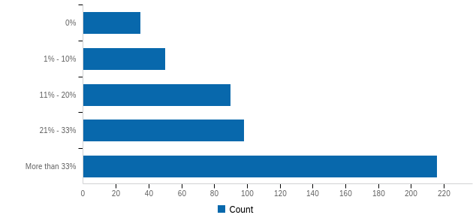
Crucially, this extra effort does not stop because an employee has received an accommodation. 86% of surveyed employees who reported asking for an accommodation received it. Despite this, 42% indicated they worked more than 33% harder than their peers. Of those who requested accommodation, only 3% indicated they worked with the same degree of effort as their peers.
Figure 2: Figure 2: How much extra effort do you make [at work] due to disability? Broken down by if respondent had requested an accommodation at work.
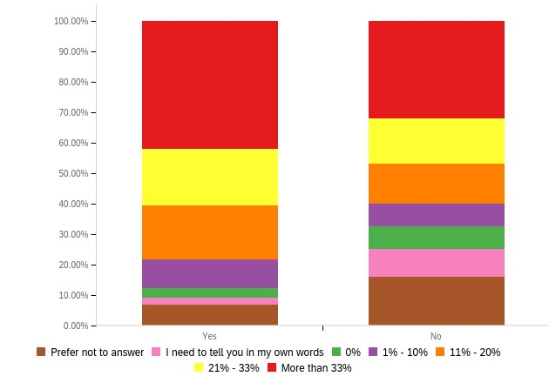
The implications of this research are clear: to maximize productivity, company culture and practice surrounding accommodation must account for high rates of non-disclosure.

Culture Shift: From inclusivity to productivity
Many top companies have made a laudable effort to change internal cultures surrounding disability. These efforts have included additional training for management, the creation of Employee Resource Groups, specific hires of PWD, and statements affirming inclusive practices. A major goal of these efforts is to broaden a culture of inclusion, making PWD more comfortable openly discussing disability and increasing the willingness of management to hire, mentor, and promote PWD within the workforce.
While a positive development, this focus on disability as primarily an issue of inclusion as opposed to one of productivity maintains a system that forces PWD to evaluate a trade-off between productivity-increasing accommodations and potential negative career implications. Our research, and that of others, has shown that the latter most frequently wins out.
It is in the best interest of firms to promote productivity adjustments (ie: accommodations) to all workers. Research has consistently shown that the cost of providing such adjustments is minimal, and that it increases productivity and job satisfaction for those that receive them. A 2023 Job Accommodation Network report indicates roughly half of workplace accommodations incurred no costs, while one-time expenditures had a median cost of $300. While ongoing accommodations had a median annual cost of $3,750, it should be noted that only 6% of surveyed employers had provided such ongoing accommodations. In the US market, tax incentives support the provision of these accommodations.
Yet, a focus on disclosure limits the number of individuals who seek adjustments. Beyond significant concerns over career prospects or stigmatization for PWD, many workers with functional limitations do not self-identify as having a disability. This is especially true for older workers who attribute changes in functionality to aging processes.
Functional disabilities are likely to develop or increase with age, regardless of whether people identify as having a disability. At the same time, workers are increasingly retiring later and taking additional post-retirement careers, provided they are in good health. Together, these observations have two important implications. First, the proportion of people in the workforce with functional disabilities in many developed countries is likely to continually increase in the next two decades. Second, functional limitations present one of the biggest barriers to workplace productivity and employee retention. To ensure productivity and retention, a growing number of employees would benefit substantively from adjustments. Yet, disclosure requirements prevent such adjustments from taking place.
To maximize employee productivity, companies should actively work to shift cultures of accommodation, making them standard offerings across their workforce.

The Case for Productivity Adjustments
Accommodations are productivity adjustments: providing the tools and environments needed to maximize the productivity of individual employees. Research conducted by RoDG has indicated that PWD know what they need to be most productive in the workplace. These insights can seed further learning on what adjustments lead to the greatest productivity gains. Employers need to provide avenues to offer and request productivity adjustments without disclosure to maximize these gains. Reframing the conversation towards productivity adjustments is likely have at least four benefits:

Increased productivity by PWD:
Disclosure represents the largest barrier to receiving a productivity adjustment. There is a real perceived risk of professional consequences when disclosing a disability to managers that is minimized by removing this requirement. It also allows for easier adjustments for those managing less-known disabilities by removing the burden of proof from the employee.

Increased productivity by “non” PWD:
The perception that “accommodations” are only available for PWD limits their use by those who do not identify as PWD. However, many employees are likely to benefit from adjustments such as differing information layouts and communication options. In addition, studies have shown that many people who might medically qualify as having an invisible medical disability are never diagnosed, and attribute their difficulties to a lack of ability. Widely available adjustments improve the productivity of these workers.

Further culture shift:
Untying productivity adjustments from conversations of disability normalizes such adjustments as an “ordinary” part of work culture. This normalization helps to mitigate feeling by PWD of being viewed differently from co-workers, does not “out” PWD when they receive an adjustment, and creates a more productive and engaged workforce.

Limit legal challenges:
Failure to meet accommodation requests can lead to legal challenges under laws such as the ADA, ACA, and EAA. While employers have typically prevailed in such challenges, standard adjustment regimes limit the risk of challenges occurring by pre-emptively solving accessibility problems before they emerge. This is especially relevant as diagnostic criteria of many disabilities are subject to change over time, especially disabilities that are less visible. Pre-empting legal challenges also mitigates the public opinion cost of such litigation and/or regulatory disputes.

Accessibility of this document
This document respects various best practices regarding accessible documents, including our choice of typeface, type size, hue contrasts, margins, document structure, and heading styles.

This document complies with all applicable EN 301 549, WCAG 2.0 and 2.1 Level A and Level AA guidelines for accessible digital documents. For alternative formats, contact Return on Disability at mark@rod-group.com. We always strive for plain language; however, we often cannot write about conformance and compliance using simpler language without losing critical meaning.
Catherine A. Okoro, Natasha D. Hollis, Alissa C. Cyrus, and Shannon Griffin-Blake, “Prevalence of disabilities and health care access by disability status and type among adults—United States, 2016”, Morbidity and Mortality Weekly Report, Vol. 67 no. 32, (2018): 882-887; Stuart Morris, Gail Fawcett, Laurent Brisebois, and Jeffrey Hughes, A demographic, employment, and income profile of Canadians with disabilities aged 15 years and over, 2017. Statistics Canada: 2018; Centers for Disease Control and Prevention. Disability and Health Data System (DHDS) [Internet]. [updated 2023 May; cited 2023 May 15]. Available from: http://dhds.cdc.gov
Graffam, Joseph, Kaye Smith, Alison J. Shinkfield and Udo Polzin. “Employer benefits and costs of employing a person with a disability.” Journal of Vocational Rehabilitation Vol. 17 (2002): 251-263; Shengli Dong and Amy R. Guerette, “Workplace Accommodations, Job Performance and Job Satisfaction Among Individuals with Sensory Disabilities”, Australian Journal of Rehabilitation Counselling Vol. 19 no. 1, (2013): 1-20.
Susanne M. Bruyère, Willian A. Erickson, and Sara Vanlooy, “Comparative Study of Workplace Policy and Practices Contributing to Disability Nondiscrimination”, Rehabilitation Psychology, Vol 49 no. 1, (2004): 28-38; Marina T. van Leeuwen, Fiona M. Blyth, Lyn M. March, Michael K. Nicholas, and Michael J. Cousins, “Chronic pain and reduced work effectiveness: The hidden cost to Australian employers”, European Journal of Pain, Vol 10 no. 2 (2006): 161-166.
Sarah von Schrader, Valerie Malzer, and Susanne M. Bruyère, “Perspectives on Disability Disclosure: The Importance of Employer Practices and Workplace Climate”, Employee Responsibilities and Rights Journal, Vol. 26 no. 4, (2014): 237-255.
Zhanna Lyubykh, Nick Turner, Julian Barling, Tara C. Reich, and Samantha Batten, “Employee disability disclosure and managerial prejudices in the return-to-work context”, Personnel Review Vol 50 no. 2 (2021): 770-778
Alicia M. Santuzzi, Pamela R. Waltz, Lisa M. Finkelstein, and Deborah E. Rupp, “Invisible Disabilities: Unique Challenges for Employees and Organizations”, Industrial and Organizational Psychology Vol 7 (2014): 204-219.
Catherine A. Okoro et al. “Prevalence of disabilities”
Sarah von Schrader, Valerie Malzer, and Susanne M. Bruyère, “Perspectives on Disability Disclosure”
Return on Disability Group quarterly survey, August 2021. N=602 self-identified PWD.
Shengli Dong and Amy R. Guerette, “Workplace Accommodations”; Sally Friedman, “Accommodation issues in the work place for people with disabilities: A needs assessment in an educational setting”, Disability, Handicap & Society Vol 8 no. 1 (1993): 3-23; D.J. Hendricks, Linda C. Batiste, and Anne Hirsh, “Cost and Effectiveness of Accommodations in the Workplace: Preliminary Results of a Nationwide Study”, Disability Studies Quarterly Vol. 25 no. 4 (2005): n.p.
Job Accommodation Network, “Costs and Benefits of Accommodation”, available at https://askjan.org/topics/costs.cfm
Julie Ann McMullin and Kim M. Shuey, “Aging, Disability and Workplace Accommodations”, Ageing and Society Vol. 26 no. 6 (2006): 831-847.
HRS Staff, Aging in the 21st Century: Challenges and Opportunities for Americans, (2017): Institute for Social Research, University of Michigan.
Barbara .G. Licht, “Cognitive-motivational factors that contribute to the achievement of learning disabled children”, Journal of Learning Disabilities Vol. 16 no. 8 (1983):483-490.
Alicia M. Santuzzi et al. “Invisible Disabilities”

